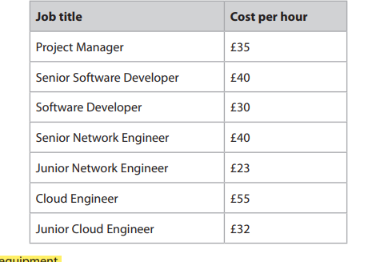 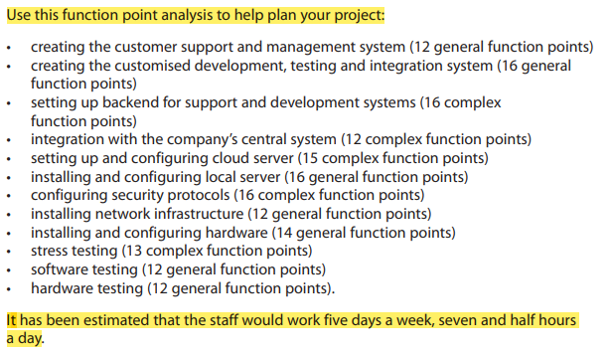

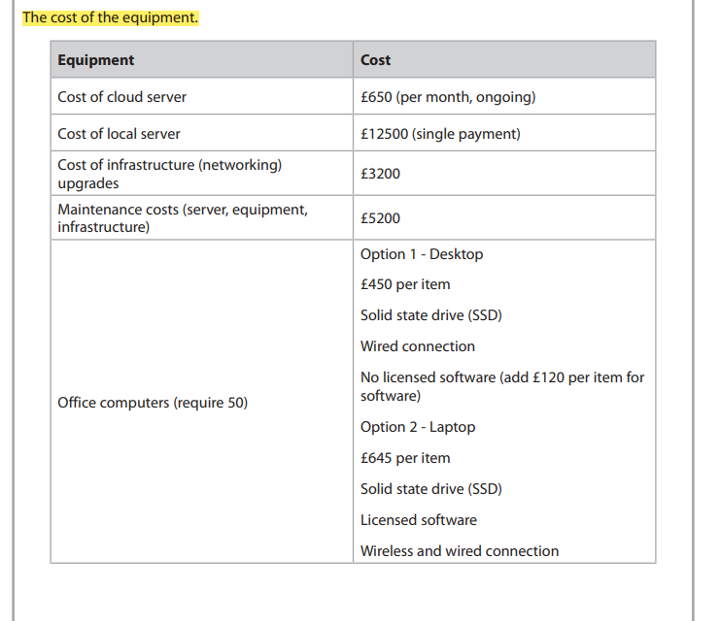

The Senior Software Developer needs **five hours per general function point** and **nine**

**hours per complex function point**. His rate of pay is given in the table.

The **Senior Software Developer** will work on £**40 p/h**

• creating the customer support and management system **12 gfp x 5 = 60 x £40 = £2400**

• creating the customised development, testing and integration system **16 cfp x 9 = 144 x £40 = 5760**

• setting up backend for support and development systems 16 **cfp x 9 = 144 x £40 = 5760**

• integration with the company’s central system **12 cfp x 9 = 108 x £40 = 4320**

• software testing.**12 gfp x 5 = 60 x £40 = £2400**

**Total = £20640**